**DAILY ONLINE ACTIVITIES SUMMARY**

|  |  |  |  |  |  |  |  |
| --- | --- | --- | --- | --- | --- | --- | --- |
| **Date:** | **15-07-2020** | | | | **Name:** | **B.A.SOHANKUMAR** | |
| **Sem & Sec** | **4TH SEM A** | | | | **USN:** | **4AL18CS013** | |
| **DESCRIPTIVE Test Summary** | | | | | | | |
| **Subject** | | **OPERATING SYSTEM** | | | | | |
| **Max. Marks** | | **30** | | **Score** | | **NOT DECLARED** | |
| **Certification Course Summary** | | | | | | | |
| **Course** | **ADVANCED STATISTICS FOR MACHINE LEARNING** | | | | | | |
| **Certificate Provider** | | | **GLA** | **Duration** | | | **5.5 HOURS** |
| **Coding Challenges** | | | | | | | |
| **Problem Statement:----** | | | | | | | |
| **Status:----** | | | | | | | |
| **Uploaded the report in Github** | | | | **YES** | | | |
| **If yes Repository name** | | | | **https://github.com/sohannaik5648987/DAILY-REPORTS** | | | |
| **Uploaded the report in slack** | | | | **YES** | | | |

**DESCRIPTIVE TEST DETAILS:**

Today there was test on OPERATING SYSTEM .The duration of the test was 45minutes from 09.30am to 10.15am.The questions were given in Google classroom and we have write it in à4 sheet and upload it to Google classroom.Score was not yet declared.

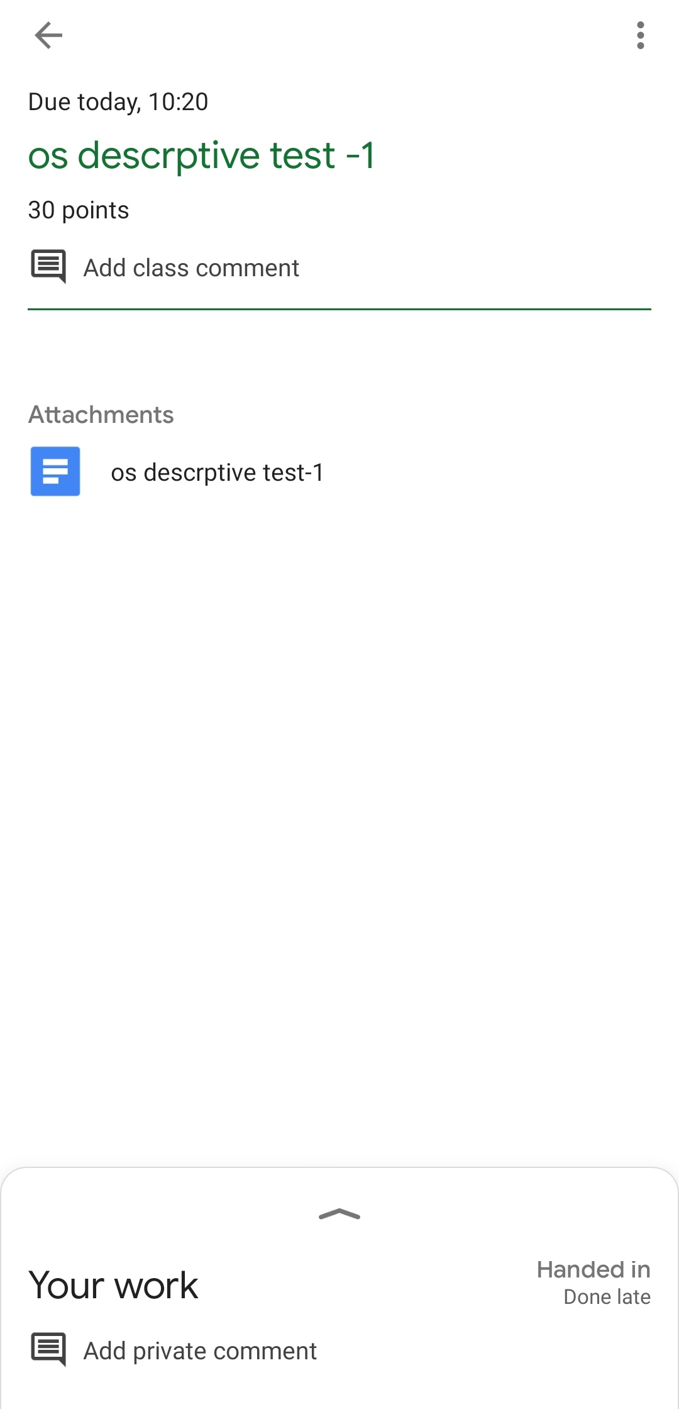

**CERTIFICATION COURSE DETAILS:**

Course: ADVANCED STATISTICS FOR MACHINE LEARNING

Completed modules today are Building Confidence Interval and Sample size problem,Null and Alternate Hypothesis,Type I and type II error,Concept of P-value,Hypothesis test example with solution,Hypothesis Formulation ExercisesT-test application- One sample problem and solution and successfully completed the course.

